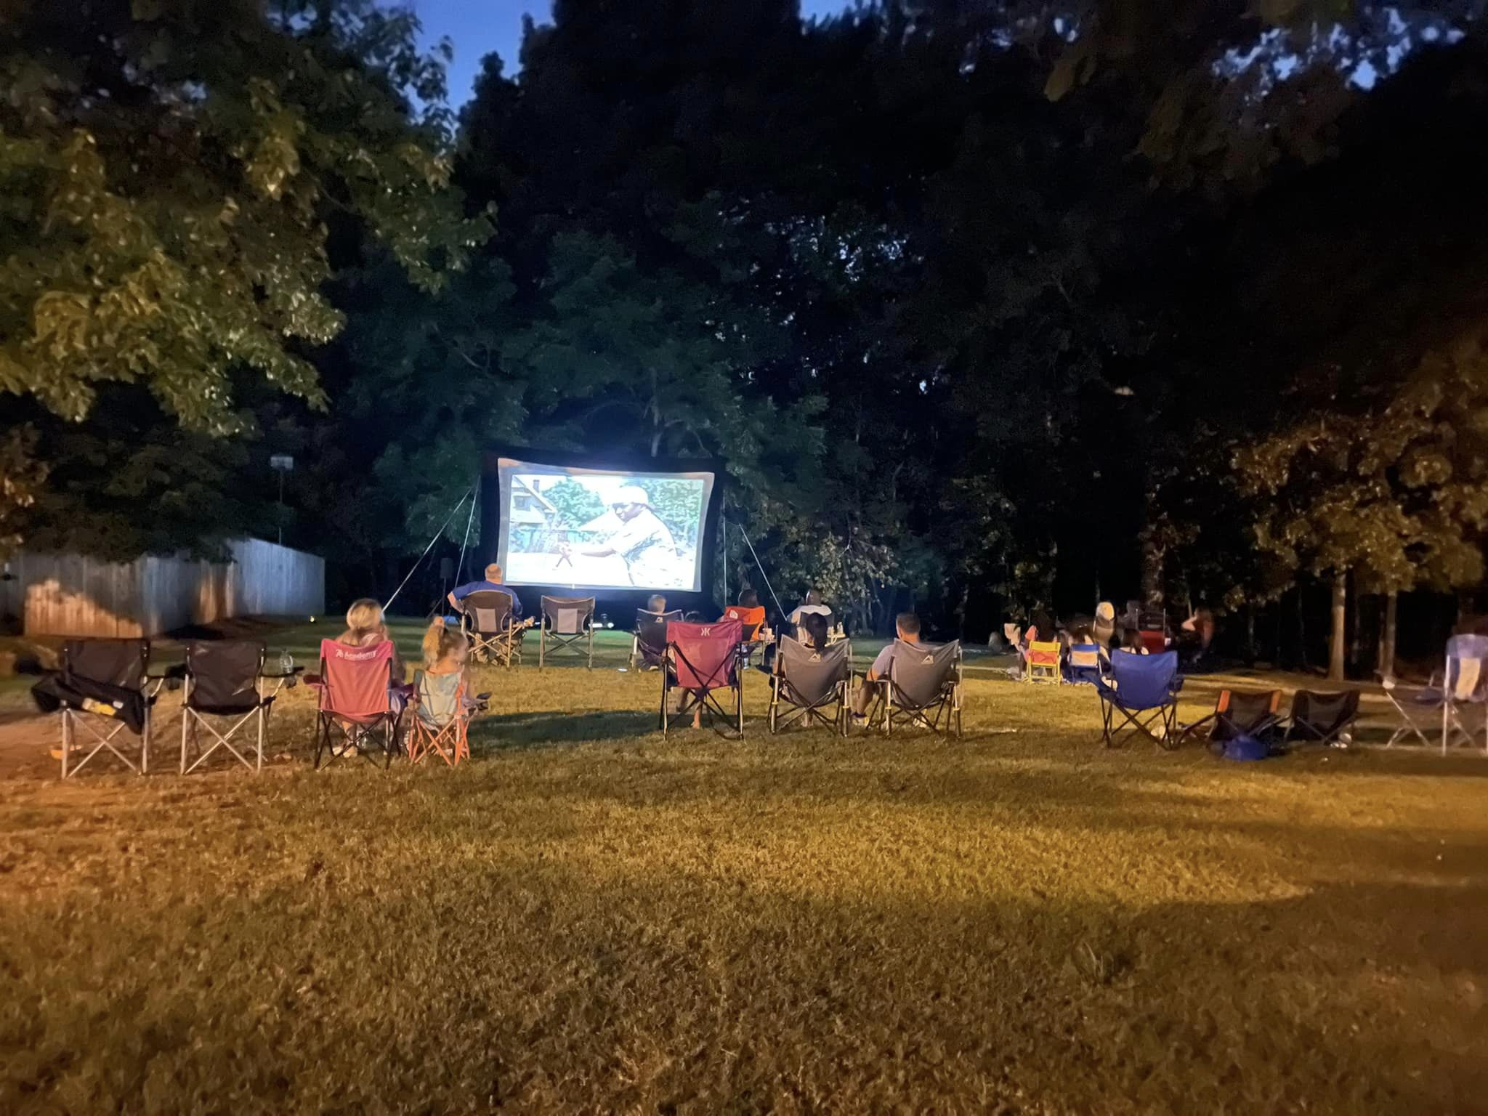

Glade Crossing hosted the first movie night under the stars in Park B on August 12, 2022.

We had approximately 34 kids and adults come out to enjoy popcorn and the adventures and shenanigans showcased in *The Sandlot*. Some families brought out their baseball gloves and enjoyed a game of catch as well. We look forward to future events. If you have ideas or suggestions for future activities or events please contact the Glade Crossing HOA Board.

